

A Project Report on

**Understanding of Complaints and Praises of Woohoo Gift card – Google Reviews**

Submitted in partial fulfilment for award of degree of

**PGDM**

In **Business Analytics**

Submitted by

**HARSHA GV**

R19MBA83

Under the Guidance of

**Jay B.Simha**

<Designation>

REVA Academy for Corporate Excellence

**REVA University**

Rukmini Knowledge Park, Kattigenahalli,

Yelahanka, Bangalore – 560064

**<Month, Year>**



# Candidate’s Declaration

I, HARSHA GV hereby declare that I have completed the project work towards the first year of Master of Business Administration in Business Analytics at, REVA University on the topic entitled “Understanding of Complaints and Praises of “Woohoo Gift card” – Google Reviews” under the supervision of Jay B.SIMHA and designation. This report embodies the original work done by me in partial fulfilment of the requirements for the award of degree for the academic year 2021.

Place: Bengaluru Name of the Student:

HARSHA GV

Date: Signature of Student



# Certificate

This is to Certify that the Project work entitled “Understanding of Complaints and Praises of “Woohoo Gift card” – Google Reviews” carried out by HARSHA GV with R19MBA83, is a bonafide student of REVA University, is submitting the first year project report in fulfilment for the award of PGDM in Business Analytics during the academic year 2021. The Project report has been tested for plagiarism, and has passed the plagiarism test with the similarity score less than 15%. The project report has been approved as it satisfies the academic requirements in respect of PROJECT work prescribed for the said Degree.

Signature of the Guide Signature of the Director

Name of the Guide Jay B.Simha Name of the Director Shinu

Guide Director

External Viva

Names of the Examiners

1. <Name> <Designation> <Signature>
2. <Name> <Designation> <Signature>

Place: Bengaluru

Date:



# Acknowledgement

Please acknowledge the role of your mentors, trainers, classmates, program office members, family and friends who have directly and indirectly supported you in this work.

Please acknowledge the support provided by Hon’ble Chancellor, Dr. P Shayma Raju, Hon’ble Vice Chancellor, Dr. M. Dhanamjaya, and Registrar, Dr. N. Ramesh, as a standard protocol.

Place: Bengaluru

Date:



# Similarity Index Report

This is to certify that this project report titled <Title of the project> was scanned for similarity detection. Process and outcome is given below.

Software Used:

Date of Report Generation:

Similarity Index in %:

Total word count:

Name of the Guide:

Place: Bengaluru Name of the Student: HARSHA GV

Date: Signature of Student

Verified by:

Signature

Dr. Shinu Abhi,

Director, Corporate Training

# List of Abbreviations

|  |  |  |
| --- | --- | --- |
| **Sl. No** | **Abbreviation** | **Long Form** |
| 1 | LSTM | Long short-term Memory |
| 2 | GRU | Gated Recurrent Unit |

# List of Figures

|  |  |  |
| --- | --- | --- |
| **No.** | **Name** | **Page No.** |
| Figure No. | Data Architecture for LSTM | 12 |
| Figure No. | CRISP-DM Methodology | 17 |

# List of Tables

|  |  |  |
| --- | --- | --- |
| **No.** | **Name** | **Page No.** |
| Table No. | Precision and Recall of the Model | 9 |
| Table No. | Matrix Predictive Parameters | 10 |

# Abstract

(Not to exceed 1-2 pages)

The Abstract is an important part of the report. It is a succinct summary of the longer report that allows the reader to quickly become familiar with the work described in the report without having to read it all. It briefly advises the reader of the problem, background information include the strategic importance of the problem, concise analysis of the problem, and the primary conclusions and recommendations. Search friendly key words to be mentioned.

**\*CRITICAL:** Do Not Use Symbols, Special Characters, Footnotes, or Math in Paper Title or Abstract.

Keywords: Text Mining, Sentiment Analysis, Natural Language Processing

# Table of Contents

Candidate’s Declaration 2

Certificate 3

Acknowedgement 4

Similarity Index Report 5

List of Abbreviations 6

List of Figures 6

List of Tables 6

Abstract 7

Chapter 1: Introduction 9

Chapter 2: Literature Review 11

Chapter 3: Problem Statement 12

Chapter 4: Objectives of the Study 13

Chapter 5: Project Methodology 14

Chapter 6: Business Understanding 15

Chapter 7: Data Understanding 16

Chapter 8: Data Preparation 17

Chapter 9: Data Modeling 18

Chapter 9: Data Evaluation 19

Chapter 10: Deployment 20

Chapter 11: Analysis and Results 21

Chapter 12: Conclusions and Recommendations for future work 22

Bibliography 23

Appendix 24

Plagiarism Report 25

Publications in a Journal/Conference Presented/White Paper 25

Any Additional Details 26

# Chapter 1: Introduction

**Background**

Gift cards, also known as gift certificates, gift vouchers, or gift tokens, are generally issued by a retailer or bank. In addition, gift cards are used as a developmental strategy for promoting businesses, attract new customers, increase brand awareness, reduce fraud, and improve business sales. Moreover, a gift card can be utilized as an alternative source for money at a particular store or business store for purchases related to goods or services.

Area of your work – Woohoo Gift Card India _ Google reviews

Company “Qwikcilver solutions Pvt Ltd” brand Woohoo gift card has more than 75% Market share in India, the Indian market is expected to grow to 9.34Billion by 2024. and Global industry is expected to grow by 2076 Billion by 2027.

**Current status**

The need for study of google reviews given for the Woohoo Gift card application in the google app store. As the brand is the number one Gift card application in India, Even though it has been in India for more than 10 Years, Still the consumers are not fully aware of the brand or concept of digital and physical gift cards. To cater to the customers better and grow faster we want to analyze the google reviews.

**Why this study**

The scope of the study is to use the Woohoo google reviews to do Text analysis and understand the Customer sentiment complaints and praises.

In the Text analysis, we are using social media and data available in the public domain to helps us understand the customer behavior, expectations, needs, and where the brand is failing to fulfill.

The study will help the organization and the gift card industry to understand from the sentiment analysis what are the factors that drive customers to buy the product, be loyal or move away from the brand due to bad delivery of service.

Sentiment analysis research is very effective in predicting positive and negative polarity ratings at different granularity at the word count used, length review written, product features performance over a period of time.

**1.1 Topic Heading**

Understanding of Complaints and Praises of “Woohoo Gift card” – Google Reviews.

**1.1.1 Sub Topic Heading**

You can write the statements here related to the sub-topic within the major topic.

**1.1.2 Equations**

Punctuate equations with commas or periods when they are part of a sentence, as in:

*a*  *b*    

**1.2 Figures and Tables**

This section describes how to place and define figures and tables.

**1.2.1 Figures**

Figures must be clearly visible and must be aligned in centre. Figure captions should be below the figures.

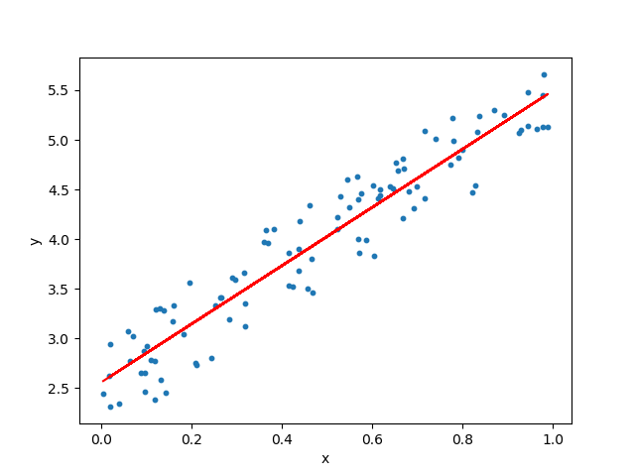

Fig 1.1: Simple Linear Regression

**1.2.2 Tables**

Tables must be aligned in centre.

Table 1.1: Table Name

| Table Head | Table Column Head | | |
| --- | --- | --- | --- |
| Table column subhead | Subhead | Subhead |
| copy | More table copya |  |  |

# Chapter 2: Literature Review

Referred the Linguistic Understanding of Complaints and Praises in User Reviews,

written by Kavitha Ganeshan, the summary of this Literature is categorizes positive and negative review sentences into 4 categories: positive only, praise, negative only and complaint. The intuition is that praise sentences and complaints tend to be more informative than plain positive only or negative only sentences. This paper thus tries to understand the properties of such text that we consider as complaints and praises. The analysis shows several interesting findings including:

complaints tend to have more past tense than the other 3 categories. complaints and praises are generally longer and contain more nouns than positive only or negative only sentences.

praise sentences tend to use more adjectives than other types of sentences.

Summary

The study has the following analysis done: -

1. In the paper they defined the Negative only, Complaint, Positive only and Praises.
2. For the defined sentiments they have shown the Avg# of words, and Avg# length Analysis.
3. Noun and adjective usage: For example, a negative only sentence such as ‘the screen is bad’ or a complaint such as ‘the screen is not clear’ both have nouns (‘screen’) and adjectives (‘bad’ and ‘clear’). Both the noun and adjectives play a role in indicating negative sentiment.
4. Paste tense analysis: By each sentiment count of Past tense words used.
5. Negation analysis: For example, consider the negation in the following sentence: this lasts all night and feels really great on my skin not oily cakey or heavy”.
6. Intensifier usage: For example, to express appreciation on some restaurant service one may say ‘The service was extremely fast and the food was super delicious!’.

title=Linguistic Understanding of Complaints and Praises in User Reviews, author=Ganesan, Kavita and Zhou, Guangyu, booktitle= Proceedings of NAACL-HLT, pages=109--114, year=2016.

In relation to our project , we have done the Woohoo gift card Google reviews to understand the sentiments , Avg #of words , Avg # of Length and compare the sentiments with product features . To help the management to work towards improving the product service and delight the customers.

**Research Gaps**

There are no research gaps, we are taking the study/research paper as reference and replicating it as case study to analyze the customers sentiments

# Chapter 3: Problem Statement

**Business Problem**

Gift card industry is available in India for more than a decade. But the product is yet to be completely accepted by customers. In order to serve the customers better and understand the concern areas. Current Penetration is around 5 to 15 % , goal is to Increase the penetration to 25% by analysing the customer complaints and Praises using the Google reviews given by customers for the past 7 years.

**Analytics Solution**

For a product to perform and meet the Expected/promised service from the beginning purchase to end service redeem of a gift card needs to be provided, there are multiple factors end-to-end work.

The problem is worth the study as it can help the existing as well any other Gift card companies on how to run the business ensuring that the customer's expectations/needs are met and kept high. Do and Don’ts to delight the customer. This would help in attract, retain and grow customers by working towards improving the customer journey and delivery process.

# Chapter 4: Objectives of the Study

The purpose of the capstone project is to understand the Customers Sentiments towards complaints, Negative only, Positive only and praises and the This would help in attract, retain and grow customers by working towards improving the customer journey and delivery process.

**Primary and Secondary objectives**

**Primary**

Increase the Penetration up to 25%

**Secondary**

Finding the areas of concern which needs to be addressed immediately

1. Application
2. Customer service
3. Delivery service
4. Product not meeting customer requirement.

**Expected outcome.**

1. Increase in customer base, loyalty and delighted customers.
2. Less attrition of customers.
3. Improvement in service delivery scores.
4. Decrease in complaints and Negative only sentiment. Increase in praise and positive only sentiment.
5. Improvement in customers experience in using the Web and mobile applications.
6. Resolving the Payment issues and More promotional offers to attract customers.

# Chapter 5: Project Methodology

**Conceptual Framework**

1. Text Cleaning.
2. Labelling the Reviews 2 class (Positive and negative) and 5 class (complaints, Negative only, Positive only and praises) to understand the sentiments.
3. Identifying the best lexicon NRC VS Vader which give better results.
4. Test the 2 class and 5 class sentiments with Naive Bayesian and SVM (support vector Machine) models.
5. Analyse the Avg word count and Avg length of the reviews
6. Analyse the complaints and Praises to generate insights
7. Analyse the product features contributing to sentiments performance over the period of time to generate insights.

**Research Design**

Leverage on Text analytics using TDSP process.

* 1. Business Understanding
  2. Data Acquisition and understanding
     1. Use web scrapping of woohoo brand Google reviews to collect customer reviews/ comments.
     2. Text cleaning
     3. Labelling 2 class and 5 Class sentiments
     4. Feature data set (Identifying and labelling features)
     5. Exploratory
     6. Document matrix (Bag of Words (BoW) using Count Vectorizer and TFIDF)
  3. Modelling – Model training and Evaluation for 2 class and 5 class sentiments
  4. Deployment
  5. Customer Acceptance

The tools used for this project for solving the problem in analyzing the sentiment mentioned below.

1. Python tool for cleaning the data, implement the Lexicon sentiments and Build Naive Bayesian Model.
2. MS Excel for reviewing, doing data review, count sentiment, word count, review length count, trend analysis and for coding the Product features.

# Chapter 6: Business Understanding

Gift Card industry complete process... to understand the business explained below

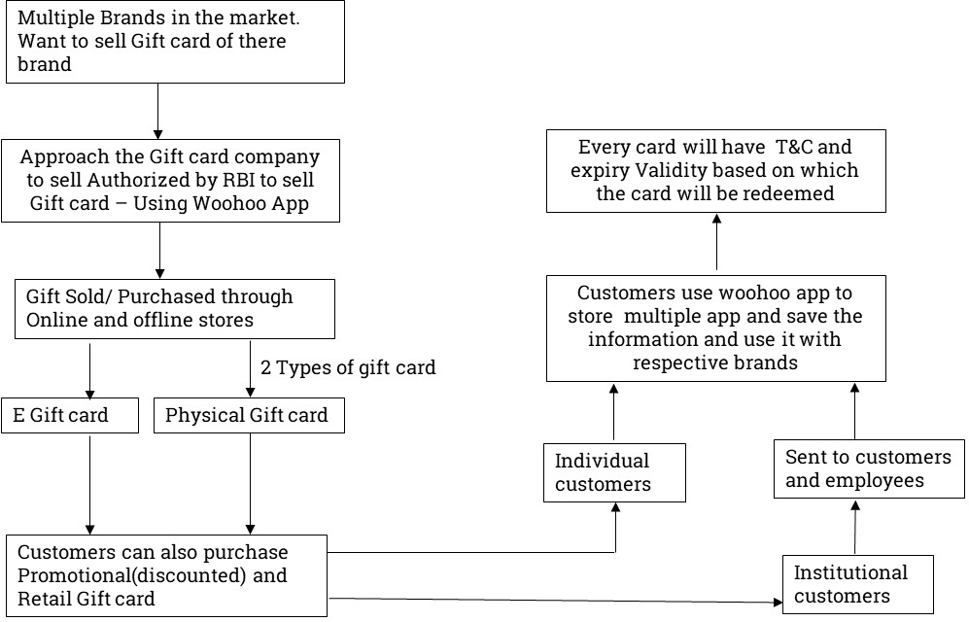

As per business understanding identified the product features. This would help us to determine if the company is providing better services to the customers.

|  |  |  |  |
| --- | --- | --- | --- |
| # | Variables | Product features | Details - Based on which we have grouped. |
| 1 | feature_negative_1 | Customer Support not good | Customer Support / Chat Support Service/ Awaiting Response/Help me issues |
| 2 | feature_negative_2 | Delivery of service not good | Delivery Service Issues / Receving, Activation, Redeem, Refund, OTP |
| 3 | feature_negative_3 | App/ Web Issues | Web App Issues / Login / UI / How to use/ App Issues |
| 4 | feature_negative_4 | Payment Issues | Payment Issues / Add other Payment Brands |
| 5 | feature_negative_5 | Promotion/offers Issues | Promotional offer Issues / less offers / Cashbacks / Add brands |
| 6 | feature_negative_6 | Validity Issues | Validity Issues |
| 7 | feature_negative_7 | Not Trusting the Brand | Un trustable / Frauds/Waste /Cheat / Fake/ not good /Scam |
| 8 | feature_positive_1 | Speed of delivery good | Faster buying process |
| 9 | feature_positive_2 | App/ Web good | Web App Good/ Nice /Great / Awesome |
| 10 | feature_positive_3 | Promotion/offers good | Best Offers Deals / Discounts |
| 11 | feature_positive_4 | Price is good | Price is good / Save Money |
| 12 | feature_positive_5 | Customer Support good | Customer Service is good |
| 13 | feature_positive_6 | Easy to use | Easy to Use |
| 14 | feature_positive_7 | Multiple Brands to choose good | Buy Wide range of brands |
| 15 | feature_positive_8 | Delivery of service good | Delivery service is Good |
| 16 | feature_positive_9 | Payment Good | Easy Payment / Multiple Payment modes |

**Challenges**

1. The technology and customers behavior will always tend to change at faster pace. We need to have robust technology, which can cater to all kind of customers individual and institutional customers.
2. Promotional/cash back offers can be provided only for some duration, so that customers get the experience of the product service. Customers always expect for offers which cannot be provided.
3. Customers are not fully aware about the Expiry date, terms and conditions so that customers redeem gift card within the time frame.

**Monetary Impact**

Increases the overall revenue by 50 crores.

<https://www.tofler.in/qwikcilver-solutions-private-limited/company/U72200DL2006PTC360078>

# Chapter 7: Data Understanding

Extracted the data 2872 records for the Woohoo Gift card from the google play app store. For the past 7 years data.

<https://play.google.com/store/apps/details?id=com.giftbig.mobile&_branch_match_id=952083693414301500>

|  |  |
| --- | --- |
| **Variables** | **Options** |
| Rating | 1, 2, 3, 4, 5 |
| Year | 2015, 2016, 2017, 2018, 2019, 2020, 2021 |
| Reviews | Customer feedback for Woohoo gift card - source google play store |

Sample Data

|  |  |  |
| --- | --- | --- |
| **Rating** | **Year** | **Review** |
| **1** | **2021** | ##10103920## case I'd Worst poor customer service they are not giving any response after 4 day's of register complaint. They call me but disconnected the call without giving any proper answer. Now I have not any way to reach customer support so I tried this.... I will never change my review..... |

# Chapter 8: Data Preparation

Pre-processing

1. Going through the reviews, manually labelling of the sentiment by 2 class, 5 class and product features.

|  |  |
| --- | --- |
| **Variables** | **Options** |
| senti_2class (Labelled) | Not Negative , Negative |
| senti_5class (Labelled) | Negative only, Complaints, Neutral, Positive only , Praise |
| feature_negative_1 | 0,1 |
| feature_negative_2 | 0,1 |
| feature_negative_3 | 0,1 |
| feature_negative_4 | 0,1 |
| feature_negative_5 | 0,1 |
| feature_negative_6 | 0,1 |
| feature_negative_7 | 0,1 |
| feature_positive_1 | 0,1 |
| feature_positive_2 | 0,1 |
| feature_positive_3 | 0,1 |
| feature_positive_4 | 0,1 |
| feature_positive_5 | 0,1 |
| feature_positive_6 | 0,1 |
| feature_positive_7 | 0,1 |
| feature_positive_8 | 0,1 |
| feature_positive_9 | 0,1 |

1. **Load the data into python and doing the preliminary analysis**
2. We have 2782 Records
3. There are Zero Missing values in the data
4. In the review’s sentiment (manually labelled the corpus ) we have 57.9% Positive and 42.1% Negative
5. **Cleaning the data by the below process.**
6. Removing special characters, punctuation, square bracket, numbers, double spacing.
7. Convert all the upper case to lower case.
8. Tokenization: Tokenization is the act of breaking up a sequence of strings into pieces such as words, keywords, phrases, symbols and other elements called tokens. We have Created the tokens in a separate column in the data frame.
9. Stop Words removal: - A stop word is a commonly used word (such as “the”, “a”, “an”, “in”) that a search engine has been programmed to ignore, both when indexing entries for searching and when retrieving them as the result of a search query. Post tokenization we have removed the stop words.
10. Stemming and Lemmatization: - Stemming and lemmatization are methods used by search engines and chatbots to analyse the meaning behind a word. Stemming uses the stem of the word, while lemmatization uses the context in which the word is being used.
11. **Document Matrix .**

Building the Document matrix (mathematical matrix that describes the frequency of terms that occur in a collection of documents) using the Bag of words (commonly used in methods of document classification where the (frequency of) occurrence of each word is used as a feature for training a classifier).

For our study used 2 Document matrix.

1. Bag of words using count vectorizer (involves counting the number of occurrences each word appears in a document)
2. Bag of words using TFIDF (Term Frequency — Inverse Document Frequency”. This is a technique to quantify a word in documents, we generally compute a weight to each word which signifies the importance of the word in the document and corpus.)

**Word cloud - Overall**

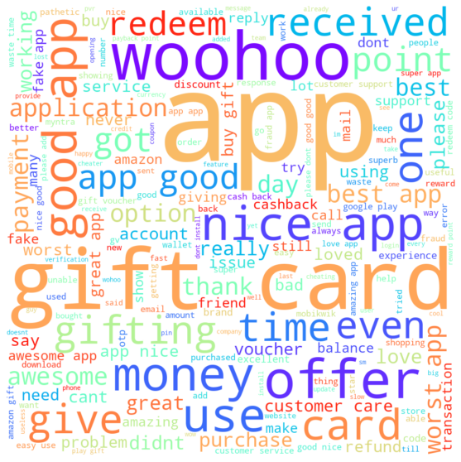

Some the key words noticed in the Word cloud.

* Woohoo
* app
* Gift card
* Money offer
* Nice app
* payment
* Best app
* Worst app
* Customer care
* Cashback
* Redeem
* Application
* Good app
* Time even
* Buy gift
* Amazing
* Give

**Word cloud - complaint**

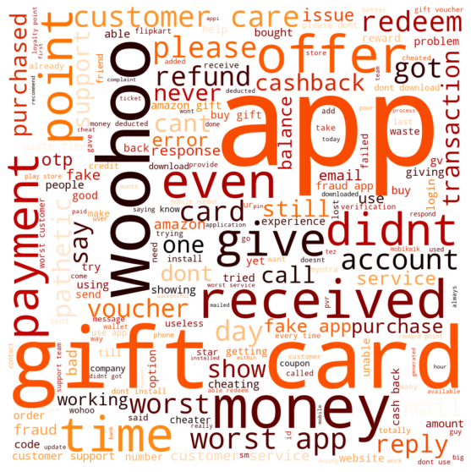

Some the key words noticed in the Word cloud.

* Worst app
* Payment
* Didn’t
* Give
* Don’t
* Fake app
* Time
* Error response
* Fraud app
* Refund
* Redeem
* Worst service
* Customer care
* Call
* Received
* Waste
* cashback

**Word cloud - Praise**

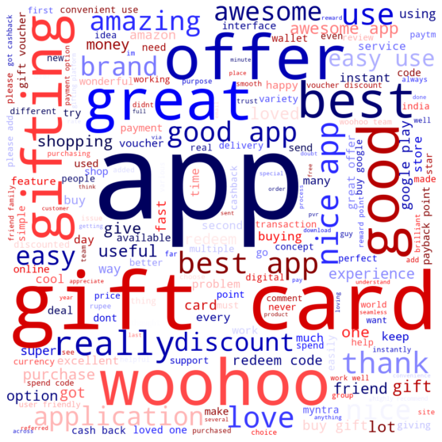

Some the key words noticed in the Word cloud.

* Great
* Good app
* Best app
* Really
* Awesome
* Best
* Nice
* Offer
* Gift card
* Woohoo
* Got cashback
* Love
* Happy
* Easy
* Super
* Amazing
* Instant discount

**Descriptive Analytics**

The following topic explained below:-

1. Trend analysis- 2 class Sentiment
2. Trend analysis- 5 class Sentiment
3. Lexicon Sentiment Analysis- 2 class
4. Cross Tab – Validation of Lexicon
5. Trend analysis- Word count and Length- 2 class
6. Trend analysis- Word count and Length- 5 class
7. Features by 5 class Sentiment
8. Trend analysis- Features- Complaint
9. Trend analysis- Features- Praises
10. **Trend analysis- 2 class Sentiment**

|  |  |  |  |  |  |  |  |  |
| --- | --- | --- | --- | --- | --- | --- | --- | --- |
| Number | 2015 | 2016 | 2017 | 2018 | 2019 | 2020 | 2021 | Total |
| Negative | 453 | 96 | 94 | 127 | 97 | 166 | 138 | 1171 |
| Not Negative | 539 | 125 | 60 | 101 | 89 | 376 | 321 | 1611 |
| Grand Total | 992 | 221 | 154 | 228 | 186 | 542 | 459 | 2782 |
|  |  |  |  |  |  |  |  |  |
| Percentage |  |  |  |  |  |  |  |  |
| Negative | 46% | 43% | 61% | 56% | 52% | 31% | 30% | 42% |
| Not Negative | 54% | 57% | 39% | 44% | 48% | 69% | 70% | 58% |
| Grand Total | 36% | 8% | 6% | 8% | 7% | 19% | 16% | 100% |

In the Year 2021 the company has the highest Positive Rating of 70% compared to previous year. But when we split for 20121 it has only 16% weighted when compared with reviewers of the total 7 years data.

In the Labelled 2 class sentiment overall, we have 59% Not Negative and 42% Negative

1. **Trend analysis- 2 class Sentiment**

|  |  |  |  |  |  |  |  |  |
| --- | --- | --- | --- | --- | --- | --- | --- | --- |
| Number | 2015 | 2016 | 2017 | 2018 | 2019 | 2020 | 2021 | Total |
| Complaint | 251 | 44 | 49 | 76 | 46 | 80 | 78 | 624 |
| Negative only | 202 | 52 | 45 | 51 | 51 | 86 | 60 | 547 |
| Neutral | 37 | 7 | 3 | 3 | 4 | 10 | 10 | 74 |
| Positive only | 381 | 84 | 47 | 87 | 78 | 277 | 218 | 1172 |
| Praise | 121 | 34 | 10 | 11 | 7 | 89 | 93 | 365 |
| Grand Total | 992 | 221 | 154 | 228 | 186 | 542 | 459 | 2782 |
|  |  |  |  |  |  |  |  |  |
| Percentage | 2015 | 2016 | 2017 | 2018 | 2019 | 2020 | 2021 | Total |
| Complaint | 25% | 20% | 32% | 33% | 25% | 15% | 17% | 22% |
| Negative only | 20% | 24% | 29% | 22% | 27% | 16% | 13% | 20% |
| Neutral | 4% | 3% | 2% | 1% | 2% | 2% | 2% | 3% |
| Positive only | 38% | 38% | 31% | 38% | 42% | 51% | 47% | 42% |
| Praise | 12% | 15% | 6% | 5% | 4% | 16% | 20% | 13% |
| Grand Total | 36% | 8% | 6% | 8% | 7% | 19% | 16% | 100% |

1. Overall: -Majority of the reviews are towards “Positive only” 42% which is good, but the company has to work towards converting the “positive only” to “Praise” . and reduce the negative only and complaints around 20% to positive only.
2. 2021: - Over the past 6 years the company has been able to improve the scores for “Positive only” for 2021 with 47%, and improved the praise to 20 %.
3. **Lexicon Sentiment Analysis- 2 class**

Sentiment analysis using the lexicons

1. Lexical Affinity. This approach trains probability from linguistic corpus. It not only detects obvious affect words but also assigns sentiment to arbitrary words.
2. NRC Lexicon Sentiment analysis: (The National Research Council Canada's (NRC) Emotion Lexicon

In the NRC lexicon we are able to understand the emotional side of the reviews along with positive and negative sentiments. 8 emotions are anger, anticipation, disgust, fear, joy, sadness, surprise and trust.

1. Vader Lexicon Sentiment analysis (Valence Aware Dictionary and sentiment Reasoner) Emotion Lexicon

In the Vader sentiment analysis, we are able to understand the Positive and negative sentiments. We rate it as Negative , positive and neutral the compound score >0 is Not negative and <0 is Negative.

We have done cross tab of the 2 Class sentiment with lexicon output to validate know which lexicon give better results.

1. Cross Tab – Validation of Lexicon

|  |  |  |  |  |  |  |  |
| --- | --- | --- | --- | --- | --- | --- | --- |
| Number | Affin | | NRC | | Vader Sentiment | |  |
| Sentiment | Negative | Not Negative | Negative | Not Negative | Negative | Not Negative | Total |
| Negative | 512 | 659 | 726 | 445 | 536 | 635 | 1171 |
| Not Negative | 8 | 1603 | 141 | 1470 | 11 | 1600 | 1611 |
| Total | 520 | 2262 | 867 | 1915 | 547 | 2235 | 2782 |
|  |  |  |  |  |  |  |  |
| Percentage |  |  |  |  |  |  |  |
| Negative | 43.7% | 56.3% | 62% | 38% | 46% | 54% | 42% |
| Not Negative | 0.5% | 99.5% | 9% | 91% | 1% | 99% | 58% |

NRC Lexicon is providing better results

Negative is 62 % which is better compared to other lexicons Vader with 46% and Affin 44% .

Not Negative is 91 % is better than other lexicons, Even though the percentage for Vader with 99 % and Affin 99.5 % is more, NRC is better as it is giving better results for negative sentiment also.

1. Trend analysis- Word count and Length- 2 class

|  |  |  |  |  |  |  |  |  |
| --- | --- | --- | --- | --- | --- | --- | --- | --- |
| **Average of Words count** | | |  | | | | | |
| Average | 2015 | 2016 | 2017 | 2018 | 2019 | 2020 | 2021 | Average |
| Negative | 22.5 | 23.3 | 22.0 | 22.0 | 19.6 | 21.2 | 22.8 | 22.09 |
| Not Negative | 9.9 | 10.2 | 7.7 | 6.7 | 4.9 | 9.4 | 10.1 | 9.27 |
| Grand Total | 15.7 | 15.9 | 16.4 | 15.2 | 12.5 | 13.0 | 13.9 | 14.67 |
| **Average of Length** | | |  | | | | | |
| Negative | 122.06 | 125.61 | 118.04 | 120.17 | 106.26 | 117.39 | 122.96 | 119.96 |
| Not Negative | 53.93 | 54.55 | 41.82 | 35.37 | 25.62 | 50.19 | 52.91 | 49.73 |
| Grand Total | 85.04 | 85.42 | 88.34 | 82.61 | 67.67 | 70.77 | 73.97 | 79.29 |

On an average number of words 14.67 Words are used in reviews and 79.29 Avg Length of the reviews.

For 2021 negative Avg # of words is around 23 and Avg. length is 123.

For 2021 not negative Avg # of words is around 10 and Avg. length is 53.

For Negative reviews the customers write more, compared to Not negative.

1. Trend analysis- Word count and Length- 5 class

|  |  |  |  |  |  |  |  |
| --- | --- | --- | --- | --- | --- | --- | --- |
| **Average of words count** |  |  |  |  |  |  |  |
| **Average** | **2015** | **2016** | **2017** | **2018** | **2019** | **2020** | **2021** | **Average** |
| Complaint | 29.09 | 35.98 | 30.80 | 28.96 | 26.76 | 29.04 | 30.58 | 29.70 |
| Negative only | 14.42 | 12.56 | 12.36 | 11.71 | 13.06 | 13.86 | 12.65 | 13.41 |
| Neutral | 3.30 | 4.57 | 1.00 | 4.00 | 1.50 | 3.20 | 4.70 | 3.43 |
| Positive only | 7.08 | 6.30 | 4.45 | 4.94 | 4.59 | 6.39 | 6.23 | 6.27 |
| Praise | 20.74 | 21.12 | 25.10 | 21.27 | 9.71 | 19.34 | 19.63 | 20.08 |
| Grand Total | 15.67 | 15.90 | 16.42 | 15.24 | 12.52 | 12.98 | 13.89 | 14.67 |
|  |  |  |  |  |  |  |  |  |
| **Average of Length** |  |  |  |  |  |  |  |
| Complaint | 158.39 | 192.82 | 164.41 | 158.21 | 147.00 | 163.00 | 165.73 | 161.94 |
| Negative only | 76.91 | 68.75 | 67.56 | 63.49 | 69.51 | 74.97 | 67.37 | 72.07 |
| Neutral | 17.54 | 20.43 | 3.33 | 19.33 | 5.75 | 17.90 | 20.50 | 17.12 |
| Positive only | 38.50 | 32.01 | 23.45 | 25.44 | 23.96 | 33.59 | 32.03 | 33.13 |
| Praise | 113.67 | 117.26 | 139.70 | 118.27 | 55.43 | 105.51 | 105.34 | 109.63 |
| Grand Total | 85.04 | 85.42 | 88.34 | 82.61 | 67.67 | 70.77 | 73.97 | 79.29 |

Complaints has the highest average for both Avg # of words 29.70 and Avg. length 162.

For the Positive only and neutral has the Lowest average for both Avg # of words < 6 and Avg. length < 33.

**Conclusion :**

Customers tend to write more when they are either very happy(Praise) or very unsatisfied(complaint)

On an average over the years the reviews Avg number of word and Avg length has reduced from 15.67 to 13.89 and 85 to 74.

**Avg # word :-**

Over the past 7 years the customers are writing very less words to express their feeling having “Praise” (2021 : 19.63) and writing more for “complaint” (2021: 30.58).

**Avg Length :-**

Complaint Length of reviews is increasing over the past years for 2021 with 165 and for praise it has reduced to 105.

1. Features by 5 class Sentiment

|  |  |  |  |  |  |  |
| --- | --- | --- | --- | --- | --- | --- |
| **Features / 5 class sentiment** | **Complaint** | **Negative only** | **Neutral** | **Positive only** | **Praise** | **Grand Total** |
| Customer Support not good | 31% | 5% | 0% | 0% | 0% | 8% |
| Delivery of service not good | 63% | 11% | 0% | 0% | 0% | 16% |
| App/ Web Issues | 65% | 46% | 1% | 1% | 1% | 24% |
| Payment Issues | 19% | 8% | 0% | 1% | 0% | 6% |
| Promotion/offers Issues | 27% | 11% | 3% | 1% | 1% | 9% |
| Validity Issues | 2% | 0% | 1% | 0% | 0% | 1% |
| Not Trusting the Brand | 63% | 20% | 1% | 0% | 0% | 18% |
| Speed of delivery good | 0% | 0% | 0% | 1% | 14% | 2% |
| App/ Web good | 1% | 3% | 0% | 49% | 82% | 32% |
| Promotion/offers good | 0% | 0% | 0% | 4% | 42% | 7% |
| Price is good | 0% | 0% | 0% | 0% | 3% | 0% |
| Customer Support good | 0% | 0% | 0% | 1% | 5% | 1% |
| Easy to use | 0% | 0% | 0% | 4% | 35% | 6% |
| Multiple Brands to choose good | 0% | 0% | 0% | 3% | 21% | 4% |
| Delivery of service good | 0% | 0% | 0% | 1% | 25% | 4% |
| Payment Good | 0% | 0% | 0% | 0% | 6% | 1% |
|  | 624 | 547 | 74 | 1172 | 365 | 2782 |

Overall 32 % of the customers feel the App/web good, 24 % of the Customers feel that there are issues in the App/ Web which needs to be fixed. 3rd highest is Not trusting the Brand having 18 %.

**Praise**

Under the Sentiments wise Praise stands significantly high with 82% customers feeling the app / web application is good.

Promotion/offers good 42% , Easy to use 35%, delivery of service is Good 25% and Access to Multiple Brands to choose for purchase 21% are the other key features customers lookout for while purchasing gift card. Brand should focus on to increase the Positive only and praise

**Complaint**

App/ Web Issues 65%, Delivery of service not good 63%, Not Trusting the Brand63%, Customer Support not good 31%, are the Key product features due to which the customers have given complaints and Negative only reviews.

Brand should focus on reducing the scores and improving the service.

1. Trend analysis- Features- Complaint

|  |  |  |  |  |  |  |  |  |
| --- | --- | --- | --- | --- | --- | --- | --- | --- |
| **Feature /Year** | **2015** | **2016** | **2017** | **2018** | **2019** | **2020** | **2021** | **Total** |
| Customer Support not good | 18% | 34% | 33% | 28% | 37% | 48% | 54% | 31% |
| Delivery of service not good | 54% | 59% | 69% | 64% | 63% | 68% | 79% | 63% |
| App/ Web Issues | 76% | 70% | 73% | 64% | 70% | 43% | 40% | 65% |
| Payment Issues | 8% | 14% | 49% | 28% | 15% | 20% | 36% | 19% |
| Promotion/offers Issues | 45% | 23% | 8% | 17% | 20% | 14% | 9% | 27% |
| Validity Issues | 3% | 5% | 2% | 0% | 7% | 1% | 1% | 2% |
| Not Trusting the Brand | 65% | 64% | 67% | 66% | 72% | 58% | 56% | 63% |
| Speed of delivery good | 0% | 0% | 0% | 0% | 0% | 1% | 0% | 0% |
| App/ Web good | 2% | 2% | 0% | 0% | 0% | 1% | 3% | 1% |
| Promotion/offers good | 1% | 0% | 0% | 0% | 0% | 0% | 0% | 0% |
| Price is good | 0% | 0% | 0% | 0% | 0% | 0% | 0% | 0% |
| Customer Support good | 0% | 0% | 0% | 0% | 0% | 0% | 0% | 0% |
| Easy to use | 0% | 0% | 0% | 0% | 0% | 0% | 0% | 0% |
| Multiple Brands to choose good | 0% | 0% | 0% | 0% | 0% | 0% | 0% | 0% |
| Delivery of service good | 0% | 0% | 0% | 0% | 0% | 0% | 0% | 0% |
| Payment Good | 0% | 0% | 0% | 0% | 0% | 0% | 0% | 0% |

**Complaint**

There are 4 areas on which the brand has to work on improving Delivery of service not good 79%, Not Trusting the Brand 56% and Customer Support not good 54% which has increased for the past 7 years

App/ Web Issues has got improved from earlier 76% to 40% and for promotional offers from 45% to 9%. Brand should focus on reducing the scores and improving the service.

1. Trend analysis- Features- Praises

|  |  |  |  |  |  |  |  |  |
| --- | --- | --- | --- | --- | --- | --- | --- | --- |
| **Year** | **2015** | **2016** | **2017** | **2018** | **2019** | **2020** | **2021** | **Total** |
| Customer Support not good | 0% | 0% | 0% | 0% | 0% | 0% | 0% | 0% |
| Delivery of service not good | 0% | 0% | 0% | 0% | 0% | 0% | 0% | 0% |
| App/ Web Issues | 2% | 0% | 0% | 0% | 0% | 0% | 0% | 1% |
| Payment Issues | 1% | 0% | 0% | 0% | 0% | 0% | 0% | 0% |
| Promotion/offers Issues | 3% | 0% | 0% | 0% | 0% | 0% | 0% | 1% |
| Validity Issues | 0% | 0% | 0% | 0% | 0% | 0% | 0% | 0% |
| Not Trusting the Brand | 0% | 0% | 0% | 0% | 0% | 0% | 0% | 0% |
| Speed of delivery good | 5% | 18% | 20% | 9% | 0% | 8% | 32% | 14% |
| App/ Web good | 80% | 68% | 70% | 73% | 57% | 91% | 87% | 82% |
| Promotion/offers good | 57% | 53% | 30% | 55% | 29% | 37% | 26% | 42% |
| Price is good | 3% | 0% | 0% | 0% | 0% | 3% | 3% | 3% |
| Customer Support good | 5% | 3% | 20% | 9% | 29% | 0% | 6% | 5% |
| Easy to use | 28% | 50% | 30% | 36% | 43% | 56% | 17% | 35% |
| Multiple Brands to choose good | 18% | 18% | 20% | 9% | 14% | 35% | 13% | 21% |
| Delivery of service good | 17% | 12% | 50% | 27% | 43% | 16% | 47% | 25% |
| Payment Good | 7% | 3% | 0% | 0% | 0% | 4% | 8% | 6% |

**Praise**

There are 4 areas on which the brand has performed well in features App/ Web good 87%, Speed of delivery 32% and Delivery of service good 47%.

Promotion/ offers good 26%, Easy to use 17% and Multiple Brands to choose good 13% It is positively contributing to praises but it has good reduced for the past 7 Years. If the score are improved it will help in getting more praises.

# Chapter 9: Data Modeling

Modeling Process

1. Post cleaning of the data (please refer the slide data preparation) we first create 2 document matrix. Bag of words using count vectorizer and Bag of words using TFIDF.
2. Split the data by Train and test for 2 different sample size 70-30 and 80 -20 split
3. Using the Train data, we build the model and apply this to test data to predict and validate the accuracy.
4. For the 2-document matrix- we use 2 models Naive Bayesian Model and Support Vector Machine Model.
5. In total 16 Model bulit, 8 models for 2 class sentiment and 4 models built for 4 class class sentiment
6. Evaluate the model based on accuracy, Precision and recall.
7. 2 Class sentiment and 5 class sentiment for both models have been built to check the efficiency of the sentiments. Based on higher accuracy recommendation can be provided to clients to improve the services.

|  |  |  |  |  |
| --- | --- | --- | --- | --- |
| Model table | 2 class | 2 class | 5 class | 5 class |
|  | 70-30 | 80-20 | 70-30 | 80-20 |
| Naive Bayesian - Bag of words - Count Vectorizer |  |  |  |  |
| Naive Bayesian - Bag of words - TFIDF |  |  |  |  |
| SVM - Bag of words - Count Vectorizer |  |  |  |  |
| SVM - Bag of words - TFIDF |  |  |  |  |

# Chapter 10: Data Evaluation

Modeling Output - comparison

|  |  |  |  |  |
| --- | --- | --- | --- | --- |
| Model output | 2 class | 2 class | 5 class | 5 class |
|  | 70-30 | 80-20 | 70-30 | 80-20 |
| Naive Bayesian - Bag of words - Count Vectorizer | 93% | 94% | 69% | 68% |
| Naive Bayesian - Bag of words - TFIDF | 93% | 94% | 70% | 71% |
| SVM - Bag of words - Count Vectorizer | 92% | 94% | 73% | 74% |
| SVM - Bag of words - TFIDF | 94% | 95% | 70% | 71% |

**2 Class sentiment**

SVM - Bag of Words (BoW) using TFIDF, with 80 train and 20 test Split for the 2-class sentiment has given higher accuracy of 95%.

**5 Class sentiment**

SVM - Bag of Words (BoW) using Count Vectorizer, with 80 train and 20 test Split for the 5-class sentiment has given higher accuracy of 74%.

**2 Class sentiment Model- Results**

SVM - Bag of Words (BoW) using TFIDF, with 80 train and 20 test Split

Classification report

|  |  |  |  |  |
| --- | --- | --- | --- | --- |
|  | precision | recall | f1-score | support |
|  |  |  |  |  |
| Negative | 92% | 95% | 93% | 226 |
| Not Negative | 97% | 94% | 95% | 331 |
|  |  |  |  |  |
| accuracy |  |  | 95% | 557 |

Confusion Matrix

|  |  |  |  |  |
| --- | --- | --- | --- | --- |
|  |  | Predictions | |  |
|  |  | Negative | Not Negative |  |
| Actual | Negative | 215 | 11 | 226 |
| Not Negative | 19 | 312 | 331 |
|  |  | 234 | 323 |  |

2 Class sentiment

SVM - Bag of Words (BoW) using TFIDF, with 80 train and 20 test Split for the 2-class sentiment has given higher accuracy of 95%.

This model is good as it has precision of identifying the Negative 92% with recall of 95%.

For the Not negative it has precision of 97% and recall of 94%.

As precision and recall are more than 92 % for both sentiments, the F1 score is also good.

**5 Class Sentiment Model- Results**

SVM - Bag of Words (BoW) using Count Vectorizer, with 80 train and 20 test Split

Classification report

|  |  |  |  |  |
| --- | --- | --- | --- | --- |
|  | precision | recall | f1-score | support |
|  |  |  |  |  |
| Complaint | 72% | 75% | 73% | 115 |
| Negative only | 66% | 61% | 64% | 111 |
| Neutral | 50% | 25% | 33% | 12 |
| Positive only | 81% | 90% | 85% | 252 |
| Praise | 62% | 43% | 51% | 67 |
|  |  |  |  |  |
| accuracy |  |  | 74% | 557 |

Confusion Matrix

|  |  |  |  |  |  |  |  |
| --- | --- | --- | --- | --- | --- | --- | --- |
|  |  | Predictions | | | | |  |
|  |  | Complaint | Negative only | Neutral | Positive only | Praise |  |
| Actual | Complaint | 86 | 25 | 0 | 1 | 3 | 115 |
| Negative only | 26 | 68 | 1 | 14 | 2 | 111 |
| Neutral | 0 | 1 | 3 | 8 | 0 | 12 |
| Positive only | 3 | 7 | 2 | 227 | 13 | 252 |
| Praise | 5 | 2 | 0 | 31 | 29 | 67 |
|  |  | 120 | 103 | 6 | 281 | 47 |  |

5 Class sentiment

SVM - Bag of Words (BoW) using Count Vectorizer, with 80 train and 20 test Split for the 5-class sentiment has given higher accuracy of 74%.

This model is good as it has precision of >66% in identifying the Negative sentiments Complaint and negative only with recall >61%.

For the Not negative it has precision of >62% in identifying Positive sentiments Praise and Positive only. and recall of 90% for Positive only and 43% for Praise.

# Chapter 11: Deployment

We will be presenting this to the company management to take appropriate steps to improve the performance.

We have trained and tested the model and got 89 % accuracy. After 6 months we can again retest the delivery of service sentiments performance.

# Chapter 11: Analysis and Results

Strength:

Weakness:

Opportunity:

Threat :

# Chapter 12: Conclusions and Future Scope

Conclusion

Future scope of study.

1. Negation handling.
2. N-grams (unigram, bigram, trigrams).
3. Noun and Adjective Usage.
4. Paste tense analysis
5. Intensifier Usage
6. Taking reviews and comments from other social media platforms Facebook and twitter.

# Bibliography

Title=Linguistic Understanding of Complaints and Praises in User Reviews, author=Ganesan, Kavita and Zhou, Guangyu, booktitle= Proceedings of NAACL-HLT, pages=109--114, year=2016.

<https://kavita-ganesan.com/complaints-and-praises/#.YQPVoI4zaHv>

Title = Lexicon-Based Sentiment Analysis of Teachers’ Evaluation, Author :- Quratulain Rajput, Sajjad Haider, and Sayeed Ghani, Hindawi Publishing Corporation Applied Computational Intelligence and So, Computing Volume 2016, Article ID 2385429, 12 pages http://dx.doi.org/10.1155/2016/2385429

<https://downloads.hindawi.com/journals/acisc/2016/2385429.pdf>

<https://www.aclweb.org/anthology/W16-0418.pdf>

<https://www.alliedmarketresearch.com/gift-cards-market>

<https://www.businesswire.com/news/home/20200921005319/en/India-9.34-Billion-Gift-Card-and-Incentive-Card-Markets-2015-2019-2024-with-Covid-19-Update-Q2-2020---ResearchAndMarkets.com>

<https://www.qwikcilver.com/>

<https://www.woohoo.in/>

# Appendix

## Plagiarism Report[1]

## Publications in a Journal/Conference Presented/White Paper[2]

## Any Additional Details

1. Turnitn report to be attached from the University.
2. URL of the white paper/Paper published in a Journal/Paper presented in a Conference/Certificates to be provided.